Problem wiht encoedr and decoder:

Encoder: Need to rmmember all the words we passed on to it and it has to generate the summary in terms of the vector.
It becomes difficult if we have more than 25 words.

Decoder:
- When dealing with some objects light there is no need of giving hell lot of sentences. There is only need for the smaller words. Just give that word as input and hat will produce the output.
- 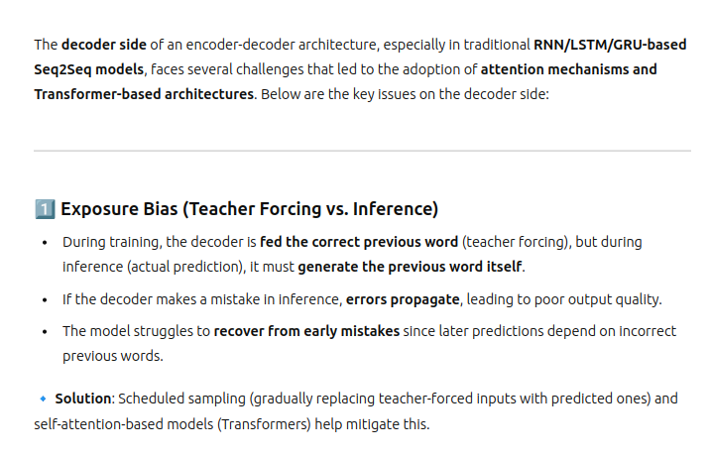
- 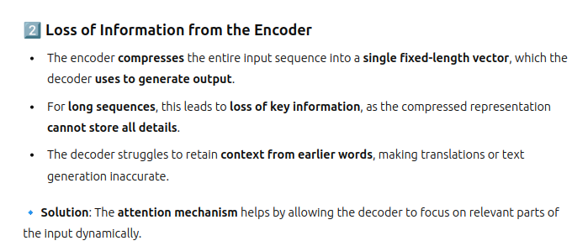
- 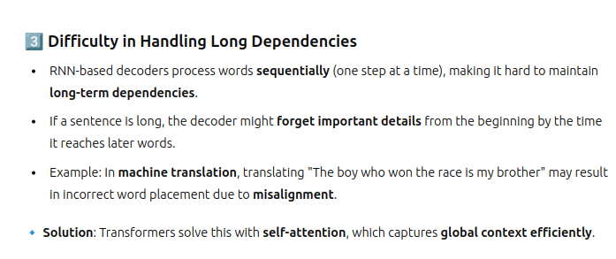
- 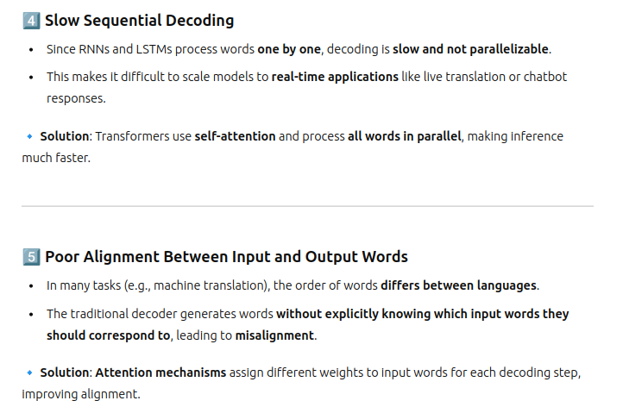
- 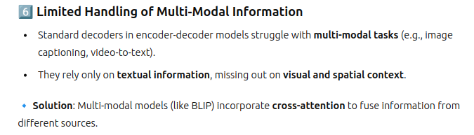
- How humans translate:
  - Humans do not translate by remembering everything in the context, they look for some potential keyword scenario, They look for all the words that are nearby based on which the translation is done.
  - So this mechanism what we need than original:
    - 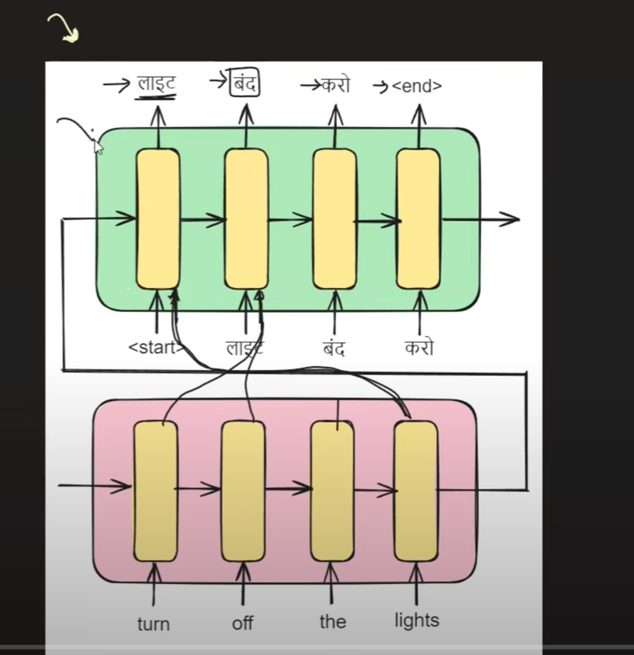
    - Duynamically it has to send the input to the decoder, which word to be given as input to which decoder, to print the correct output.
- Attention mechanism(DYNAMICALLY CHOOSES WHAT TO BE DONE):
  - 
  - 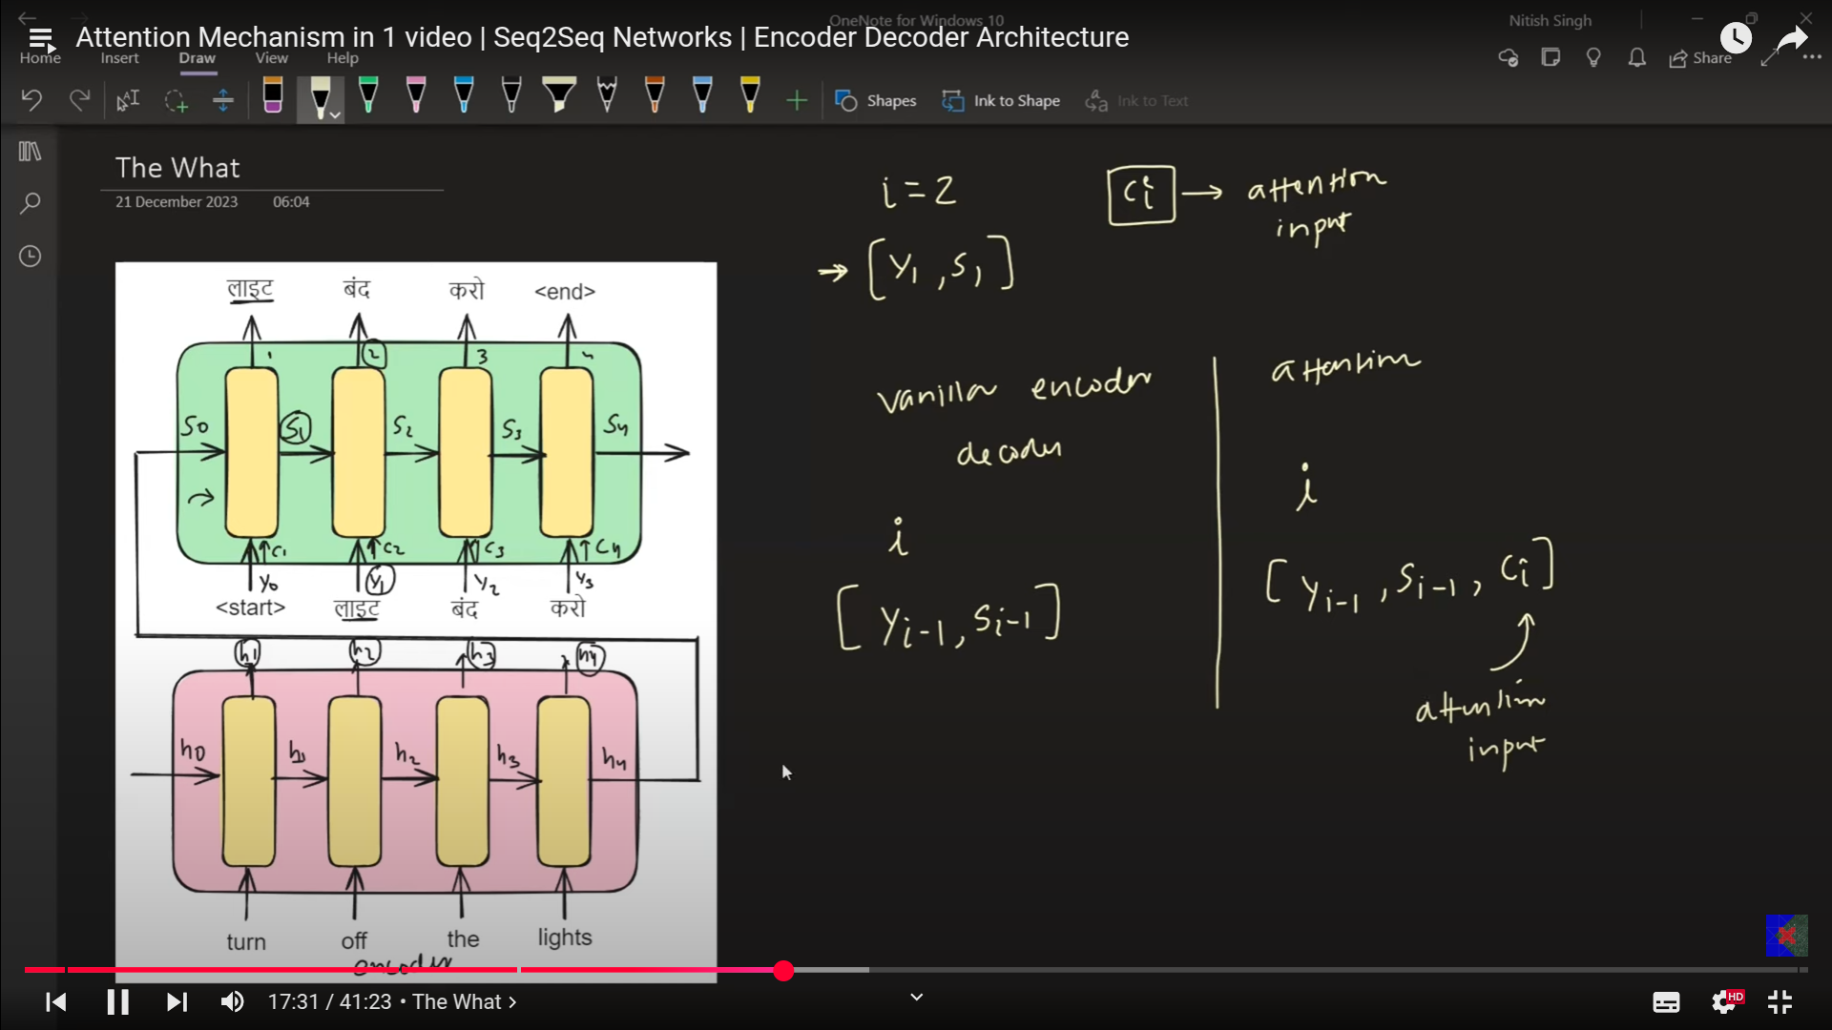
  - Ci - This decides which is helpful from decoder point of vie which must be taken as input from the encoder.
    - Ex: t=1: The use of the decoder is to keep the lights(h4) into the (c1) , that is the only use of the c1.
    - t=2: Keep the h1, h2 to c2, this is the work need to be done using the Ci, at time =2.
    - That is the reasn why Ci must be the vector. So Ci can hold one value , 2 value or 3 value at a time, that has to be passed on to the decoder.
- Ci is a vector, which must have the same nodes of lstm = same number of vectors. 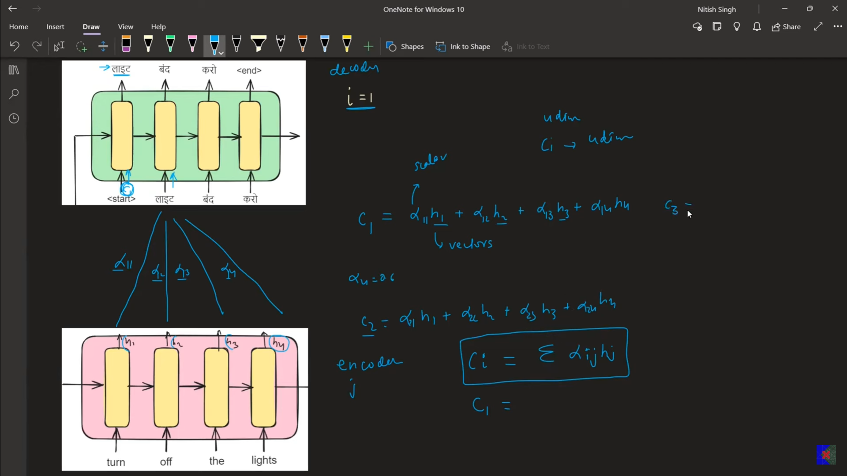
- 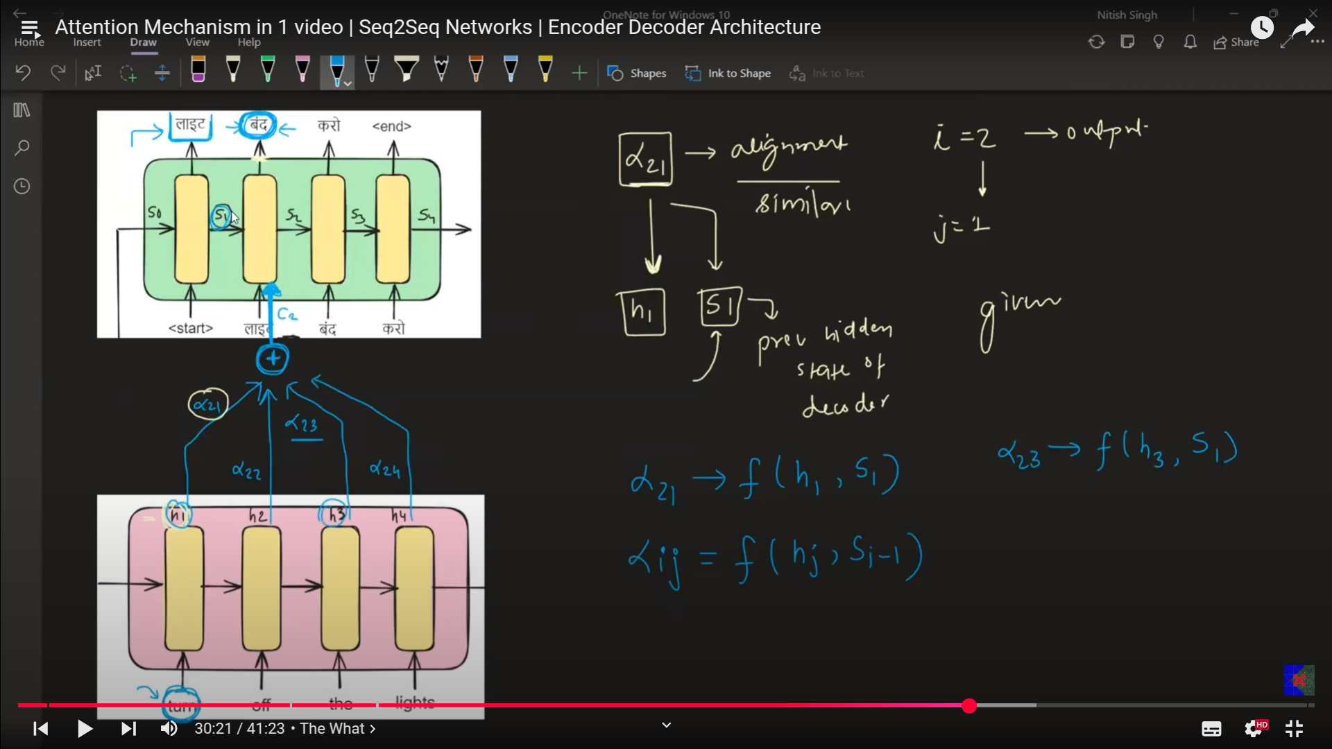
- For the decoder we pass the context vector, which is represented in C, c1, c2, c3, c4 , which takes 2 different inputs.
- 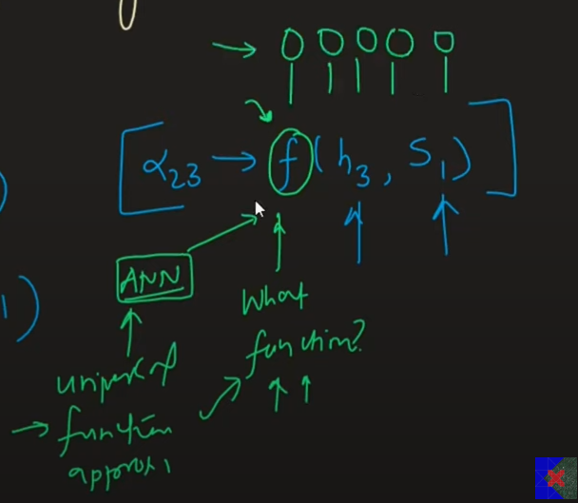
- 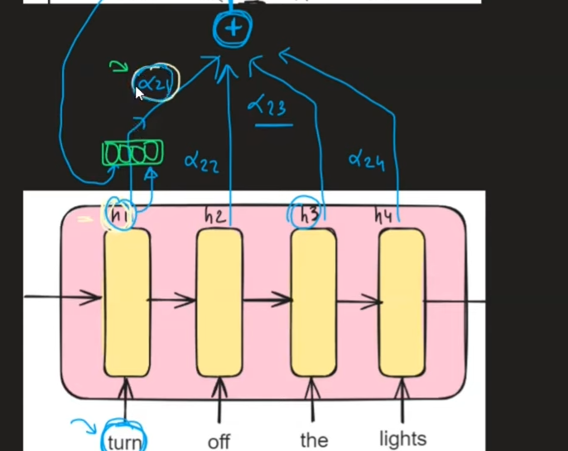
- So based on decoder and encoder not only the weights and baiases are updated in back propagation algorithm, but also helps in adjustin the weights of ANN.
- 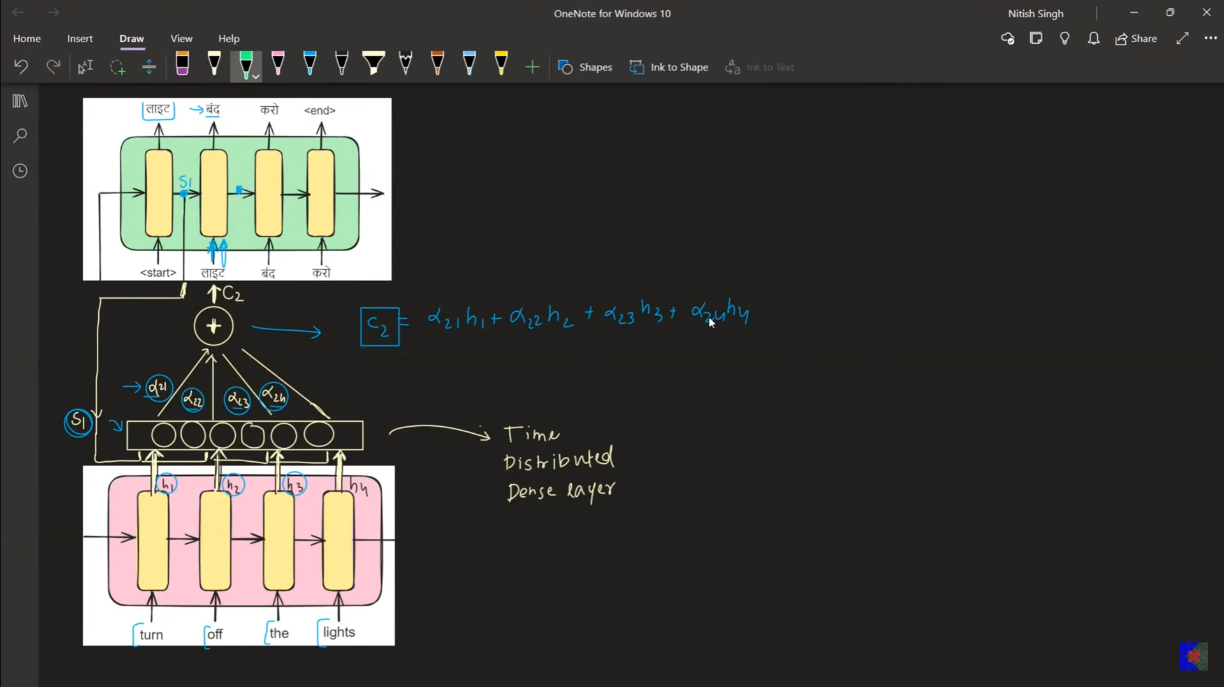
- 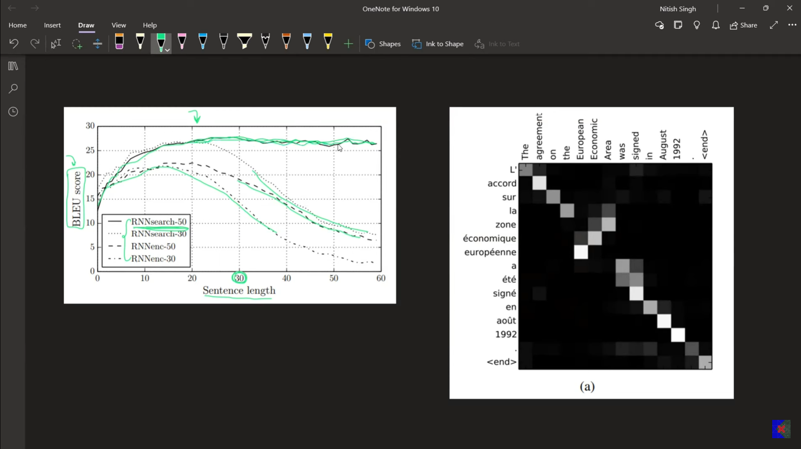
- The one mentioned in green is having the attention mechanism.
- 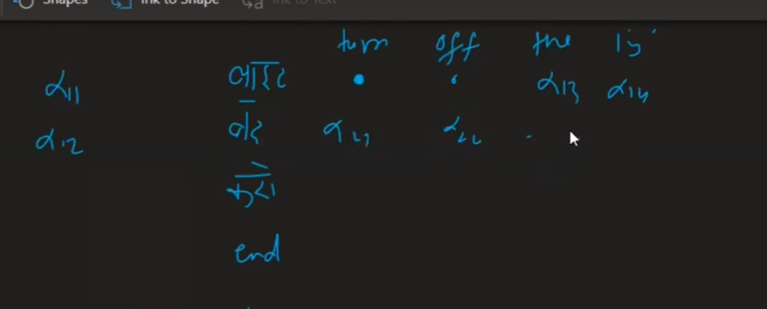
- 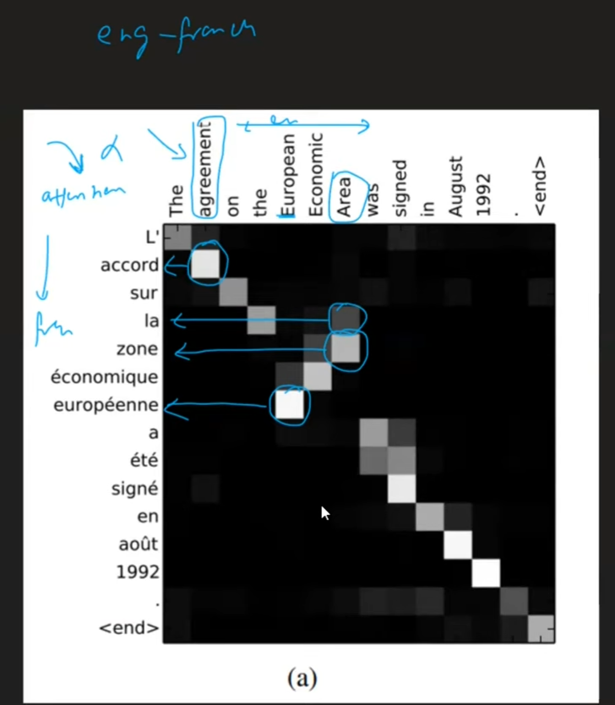
- 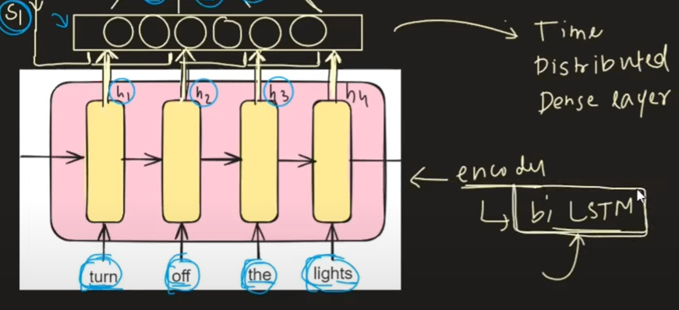
- 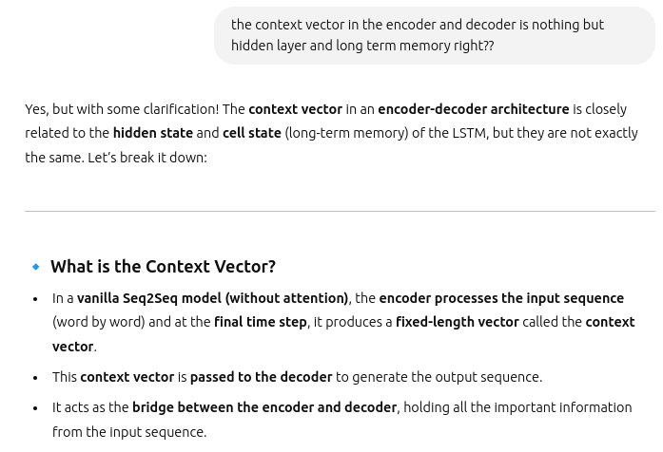
- 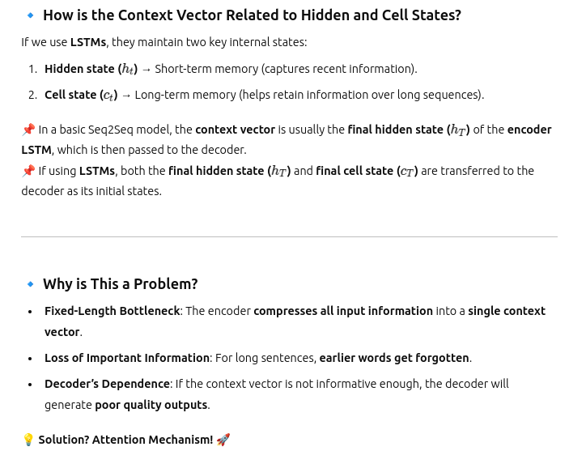
- 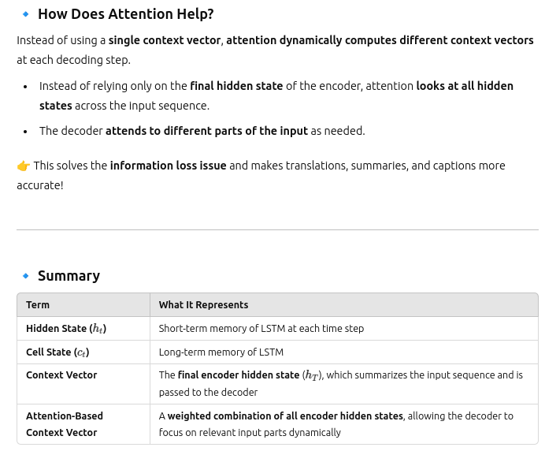
- 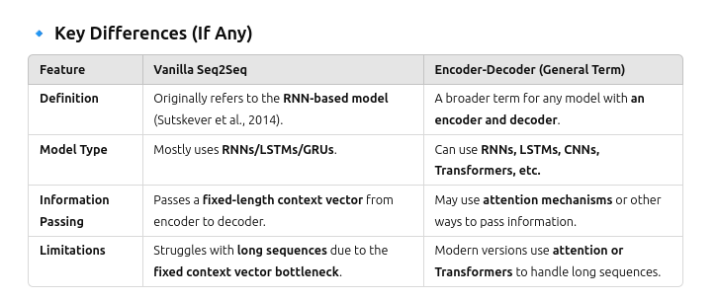
- This is the difference between the encoder decoder and attentio mechanism is:
  - 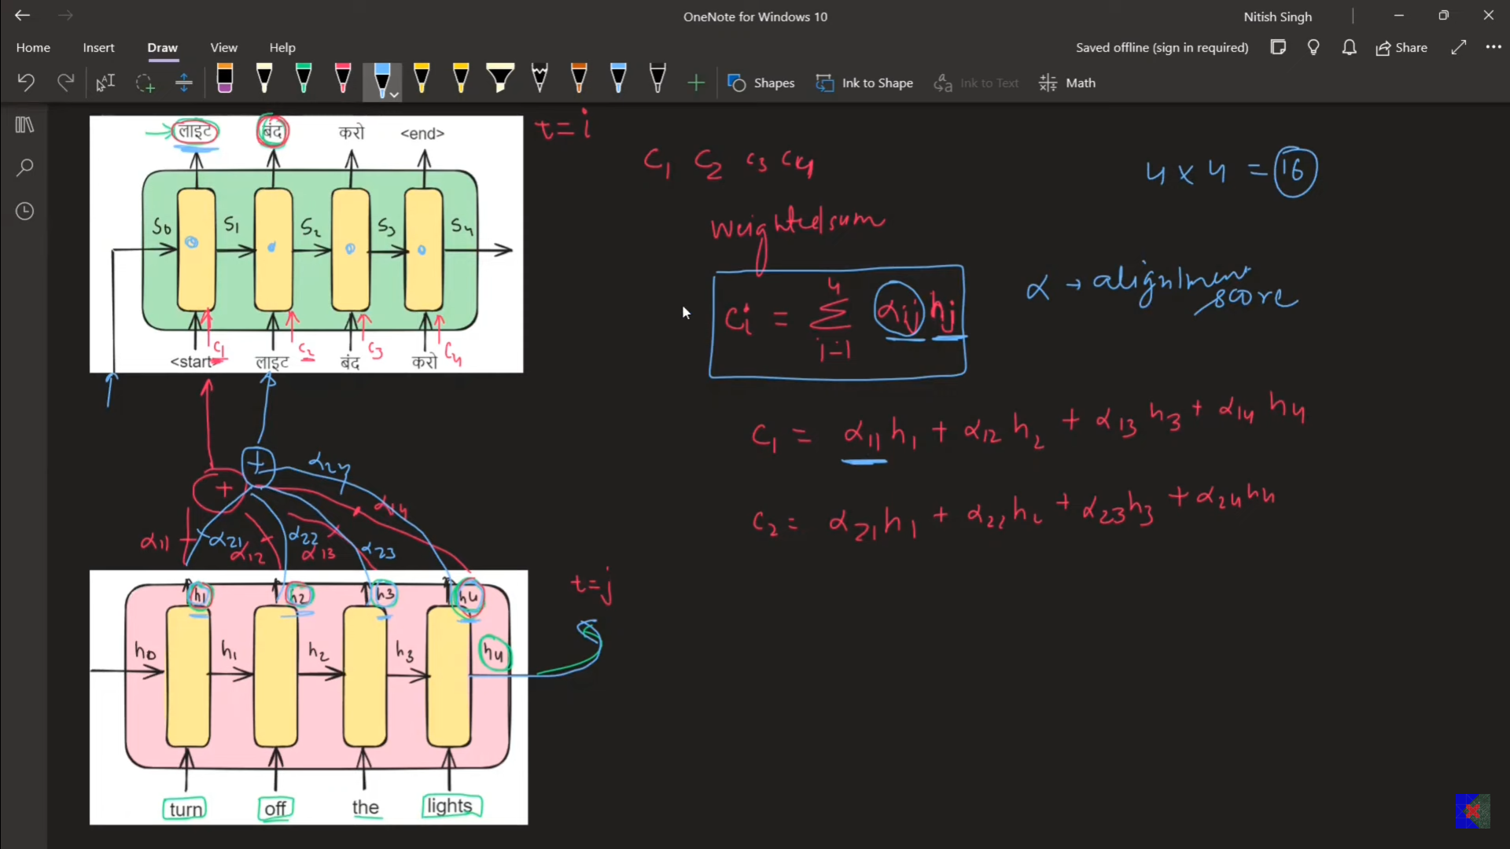
  - The alpha is used to tell regarding what is the

Types of attention
- 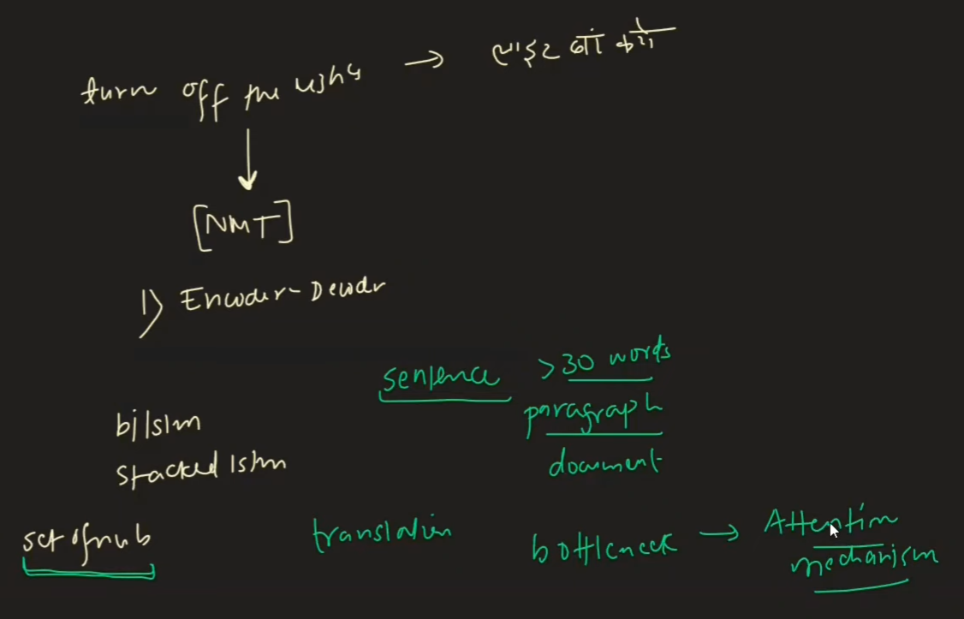

- s

